Problem 1 Testing Screenshot:

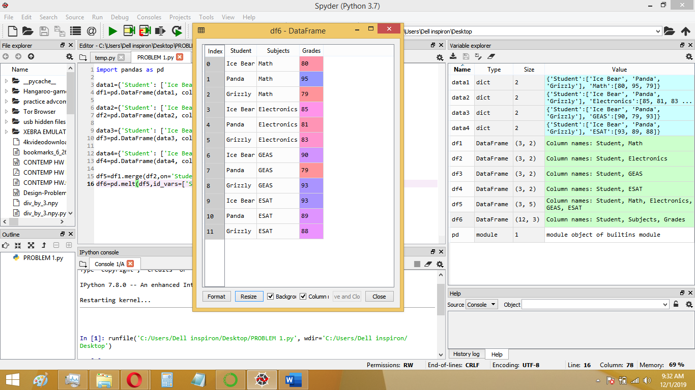

Problem 2 Testing Screenshot:

